Bonnington Symbol System
City of Edinburgh Council

Symbol resource 2008

including relevant British Standard symbols from BS 8501

Activities
Catering
College
Environments
Health
Home
People
Self development



clinics and treatments
mental health
healthcare providers
sexual health




The Resource
This resource has been created as a series of word documents which may be printed out to use as a visual reference and index.

Copy and Paste/Instructions
To reproduce an image:
- Single click on the image ensuring it is selected
- Select Copy from the Edit menu (or use keyboard shortcut Ctrl+C)
- Open the document you wish to place the image in (e.g. word document)
- Select Paste from the Edit menu (or use keyboard shortcut Ctrl+V)

Images may be resized by dragging in or out from a corner, images may be resized up to A4 without any loss of quality.

Images may be placed in tables or text boxes.

If you have any difficulty using any of the images please contact BSS using the contact details below.

Acknowledgement British Standards: Permission to reproduce extracts from the BS 8501:2002 is granted by BSI. The British Standards can be obtained from BSI Customer Services, 389 Chiswick High Road, London W4 4AL. Tel +44 (0)20 8996 9001

Acknowledgement BSS Edinburgh Council: Permission to reproduce BSS symbols is granted by The City of Edinburgh Council Health and Social Care; however reproduction of any part of the CD ROM in any form is not permitted.

Disclaimer: The City of Edinburgh Council cannot accept any responsibility for damage caused to your computer or data whilst using this CD.

Contact information: Gordon Fraser, Performance Review Manager. The City Of Edinburgh, Health and Social Care, Waverley Court, 4 Market Street Tel: +44 (0)131 553 8266
www.edinburgh.gov.uk/internet/social_care/CEC_learning_disability

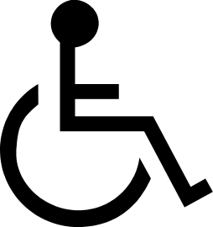 | 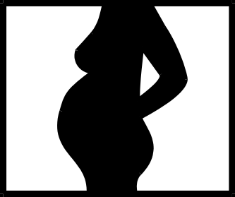 | 
Accessible facility  BS 8501 4106 | Clinic-antenatal  5000 | Clinic-arthroplasty  5001
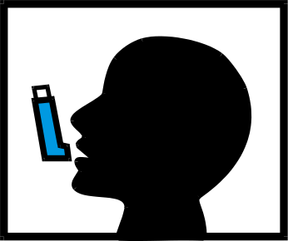 | 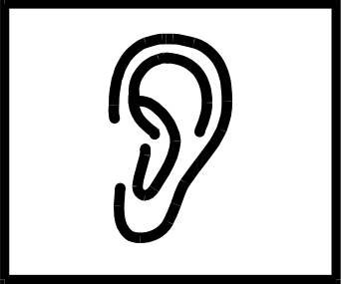 | 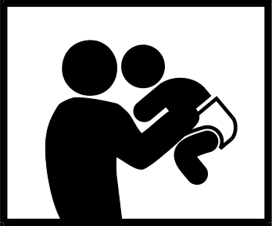
Clinic-asthma  5002 | Clinic-audiology  5003 | Clinic-baby clinic  5004
 | 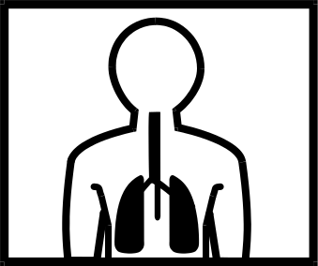 | 
Clinic-cardiology  5005 | Clinic-COPD  5006 | Clinic-dental  5007
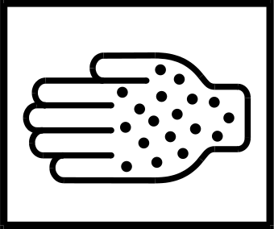 |  | 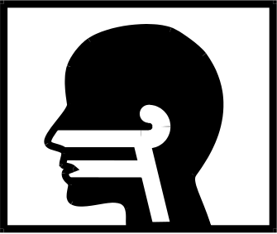
Clinic-dermatology  5008 | Clinic-diabetes  5009 | Clinic-ear nose and throat  5010
Bonnington Symbol System
www.edinburgh.gov.uk
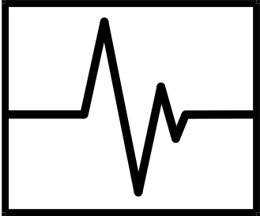 | 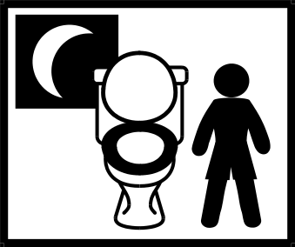 | 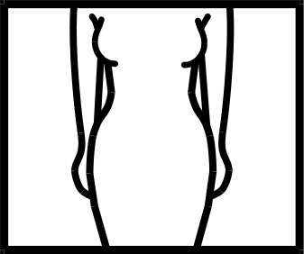
Clinic-electrocardiogram  5011 | Clinic-enuresis  5012 | Clinic-gynaecology  5013
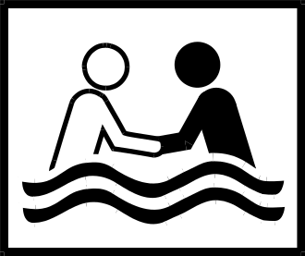 | 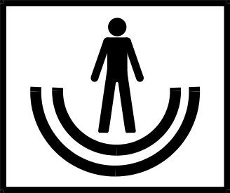 | 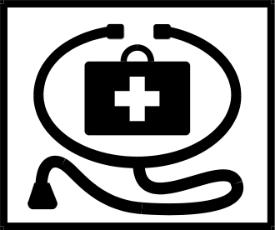
Clinic-hydrotherapy  5014 | Clinic-learning disability support  5015 | Clinic-medical  5016
 | 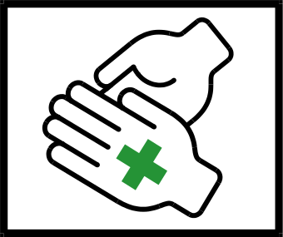 | 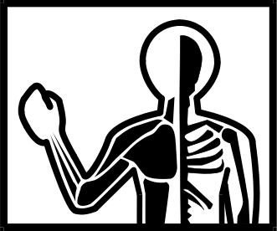
Clinic-memory  5017 | Clinic-minor surgical  5018 | Clinic-muscular skeletal  5019
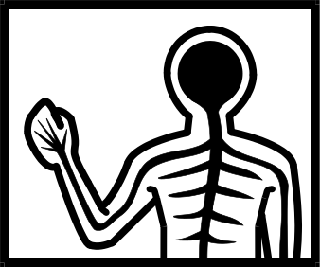 | 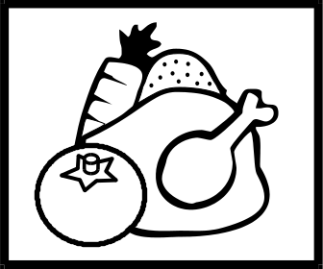 | 
Clinic-neurology  5020  Bonnington Symbol System  www.edinburgh.gov.uk | Clinic-nutrition  5021 | Clinic-ophthalmology  5022
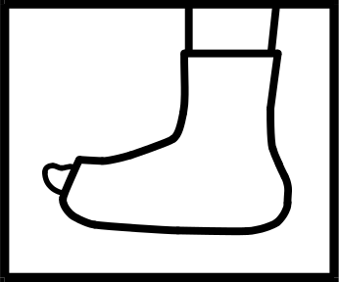 | 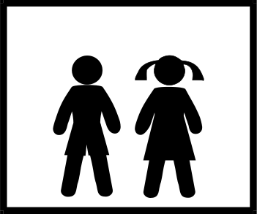 | 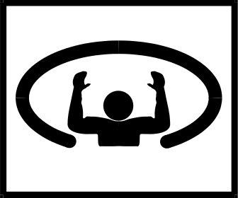
Clinic-orthopaedics  5023 | Clinic-paediatrics  5024 | Clinic-physiotherapy  5025
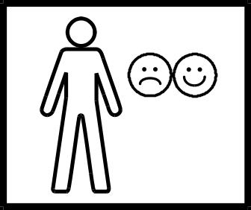 | 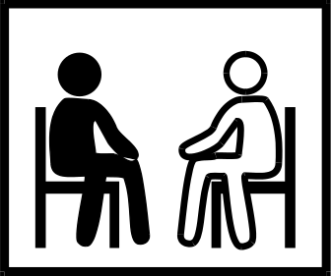 | 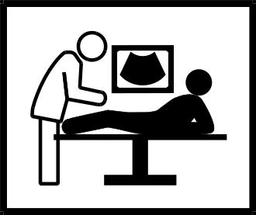
Clinic-psychiatry  5026 | Clinic-psychology  5027 | Clinic-radiography  5028
 | 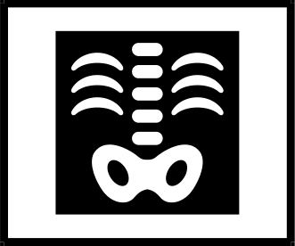 | 
Clinic-rheumatology  5029 | Clinic-x-ray  5030 | Communication  5031
 |  | 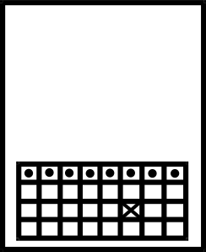
Communication support  5032  Bonnington Symbol System  www.edinburgh.gov.uk | Confidential information  5033 | Date  5034
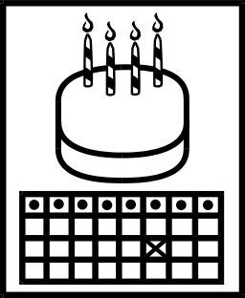 |  | 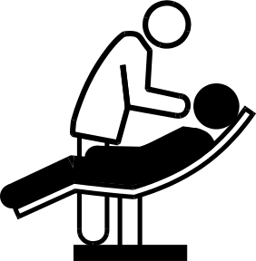
Date of birth  5035 | Day time  5036 | Dental examination  5037
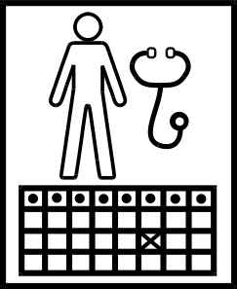 | 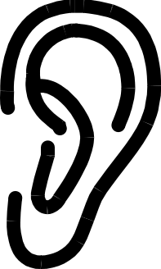 | 
Doctors appointment  5038 | Ear  5039 | Eye  5040
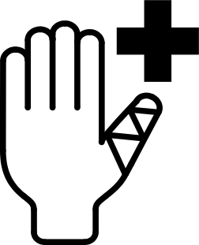 |  | 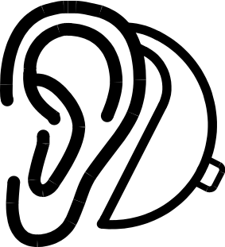
First aid  5041 | Health  5042 | Hearing aid  5043
 |  | 
Homeopathy  5044 | Information  BS 8501 6001 | Mobility  5045
Bonnington Symbol System
www.edinburgh.gov.uk

 |  | 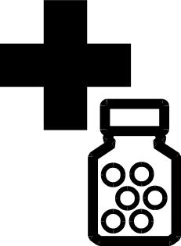
My health  5046 | Night time  5047 | Pharmacy  5048
 |  | 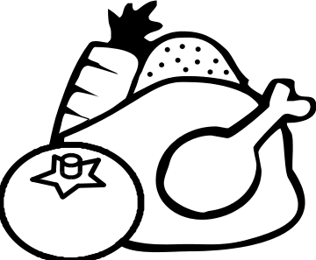
Prescribed treatment-bed rest  5049 | Prescribed treatment- exercise  BS 8501 4122 | Prescribed treatment-healthy diet  5050
 | 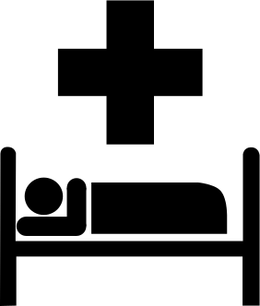
Prescribed treatment-hospital outpatients appt.  5051 | Prescribed treatment-hospital stay  BS 8501 6016 | Prescribed treatment-medication  5052
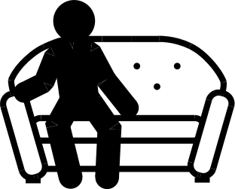 |  | 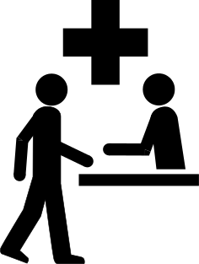
Prescribed treatment-rest  5053  Bonnington Symbol System  www.edinburgh.gov.uk | Prescribed treatment-stop smoking  BS 8501 6029 | Reception health centre  5054

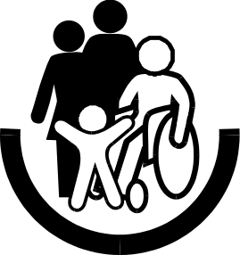 |  | 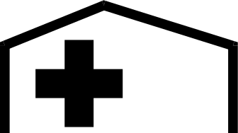
Social work  5055 | Spectacles or glasses  5056 | Surgery  5057
 |  | 
Telephone  BS 8501 6003 | Therapy-aromatherapy  5058 | Therapy-art therapy  5059
 | 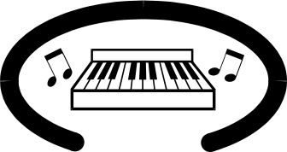 | 
Therapy-movement therapy  5060 | Therapy-music therapy  5061 | Therapy-occupational therapy  5062
 | 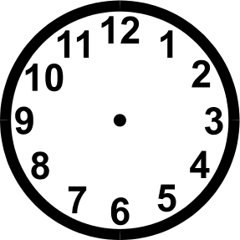 | 
Therapy-speech and language  5063  Bonnington Symbol System  www.edinburgh.gov.uk | Time  5064 | Toothbrush  5065
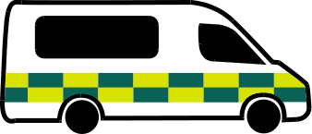 |  | 
Transport-ambulance  5066 | Transport-car  5067 | Transport-public transport  5068
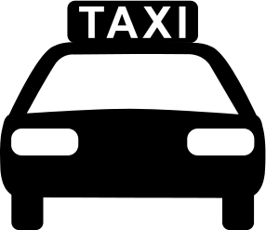 | 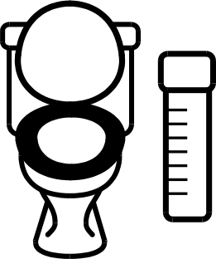 | 
Transport-taxi  BS 8501 7007 | Urine specimen #1  5069 | Urine specimen #2  5070
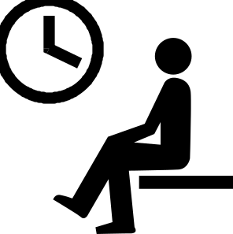
Waiting area
BS 8501 7048

Bonnington Symbol System
www.edinburgh.gov.uk

